PSTC – Kalinga Innovation, Setup, & Project Locator

USERS MANUAL

Provincial Science and Technology Office – Kalinga

1st Batch 2025

LODIxR Project

(League of Developers Initiative by the Regions Project)

Karl Jasper G. Del Rosario

Benjamin S. Tumbaga Jr.

Justin G. Bonagan

PSTC – Kalinga Innovation, Setup, & Project Locator is a web-based application developed to support the Provincial Science and Technology Center (PSTC) – Kalinga in efficiently managing and showcasing various Science, Technology, and Innovation (STI) projects, including those under the Small Enterprise Technology Upgrading Program (SETUP) and other DOST-assisted initiatives.

The system allows users to:

* Locate projects on an interactive map
* View and create project details
* Access information about local innovations and support services

Developed using PHP (Laravel) and integrated with MapLibre GL JS, the application provides an intuitive interface for navigating the geographic distribution of PSTC-supported projects within Kalinga Province.

**Getting Started:**

1. Open the application and wait 5-10 seconds (it will automatically direct you to the web system)



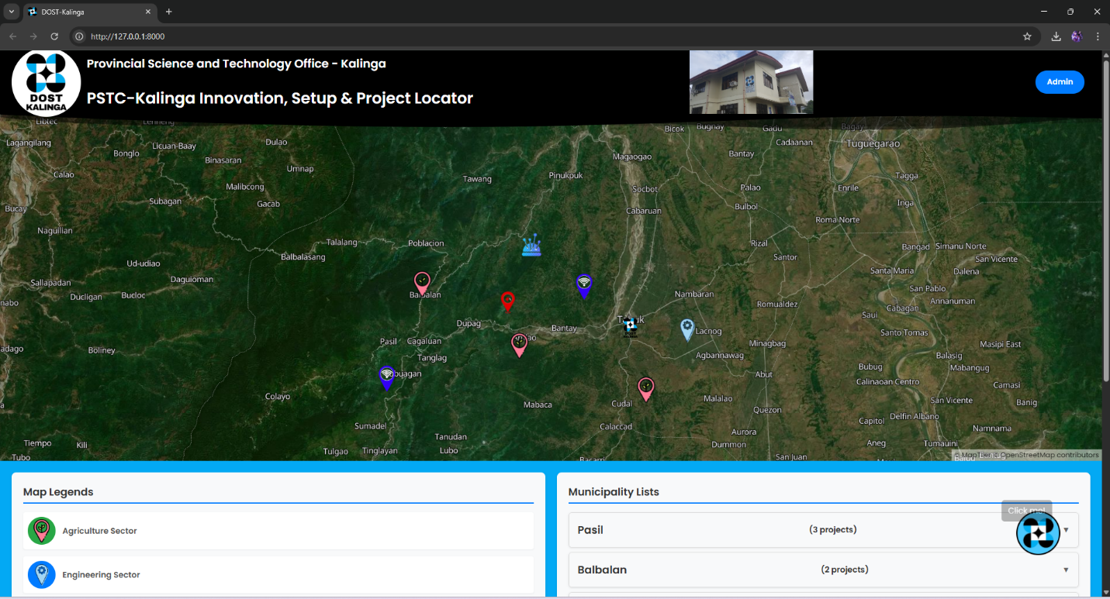

1. To go to the admin page, click the admin button top right of the system

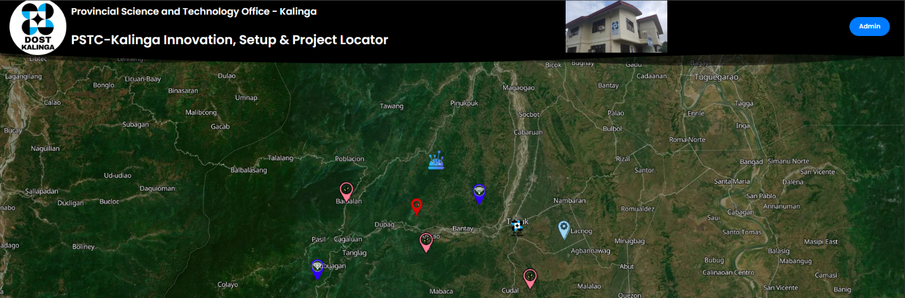

3. Enter Credentials

**Admin Button**

Username: **PSTO_Kalinga**

Password: **dost_kalinga_3800_kj**

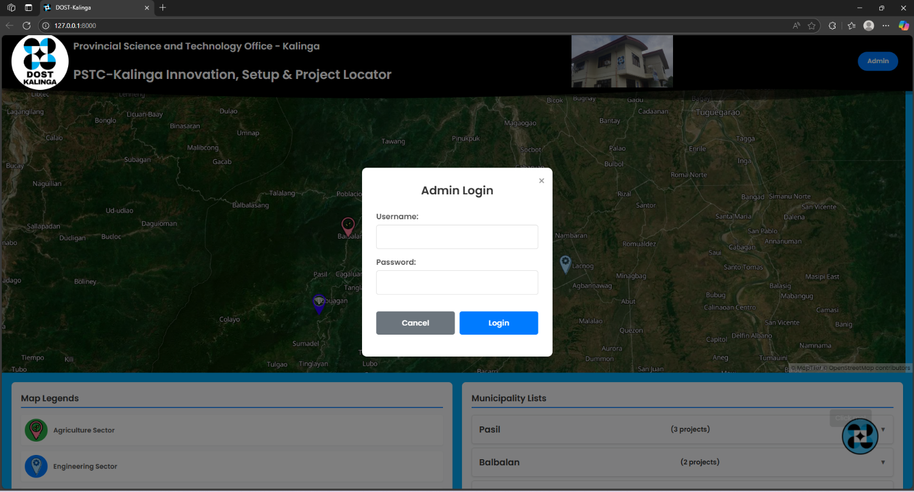

4. Closing the system

1st: Stop the Apache and Mysql and close

2nd: Close the Command Prompts

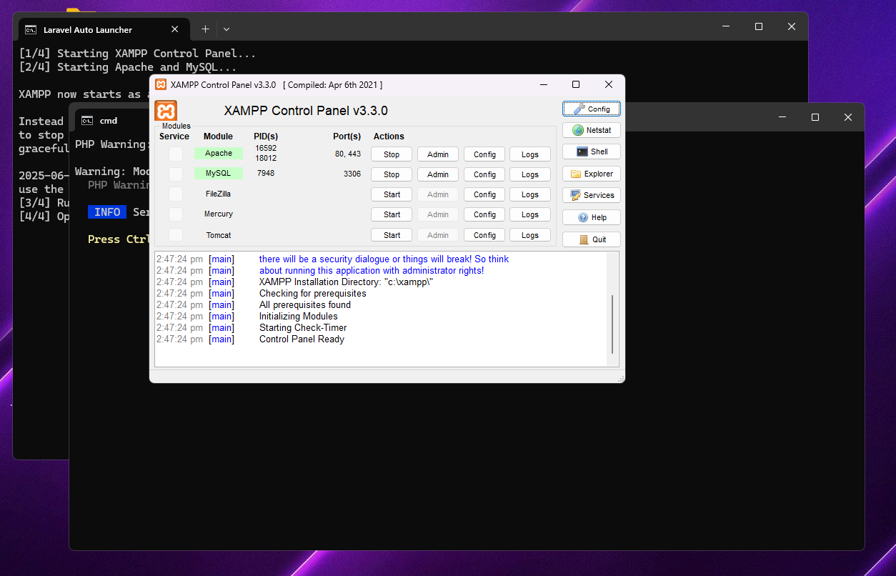

**3**

**2**

**1**